**TEST CASE-3 (Used Jira Format)**

**Title**:

Validate an Employer can edit Employee

**Description**:

**Summary**:

This test cases validates that an Employer can edit the Employee on the Benefits Dashboard.

**Features to be Tested**:

1. User Story Scenario-3
2. Benefits Dashboard
3. Edit an existing Employee
4. Benefits Cost Calculations

**Acceptance Criteria**:

User Story: As an Employer, I want to input my employee data so that I can get a preview of benefit costs.

Scenario 3: Edit Employee

GIVEN an Employer

AND I am on the Benefits Dashboard page

WHEN I select the Action Edit

THEN I can edit employee details

AND the data should change in the table

**Pre-Requisites**:

1. Have the Login page URL

<file:///C:/Users/hkapalavai/Documents/HariOldComputer-Documents/Hari/Personal%20files/City/city%20QA%20Challenge/login.html>

1. Employer Login credentials

|  |  |  |
| --- | --- | --- |
| S.No | User Name | Password |
| 1. | testUser | Test1234 |

1. Assumptions
   1. All employees are paid $2000 per paycheck before deductions
   2. There are 26 paychecks in a year
   3. The cost of benefits is $1000/year for each employee
   4. Each dependent incurs a cost of $500/year
2. On Benefits Dashboard, have at least one Employee with the following information as an example

|  |  |
| --- | --- |
| ID | 1 |
| Last Name | Zack |
| First Name | Siler |
| Salary | 52000 |
| Dependents | 1 |
| Gross Pay | 2000 |
| Benefit Cost | 57.69 |
| Net pay | 1942.31 |
| Actions | Edit, Delete |

1. Refer Test Cases -1 and 2.

**Test Details**:

|  |  |  |  |  |
| --- | --- | --- | --- | --- |
| **S.No.** | **Test Step** | **Expected Result** | **Status** | **Defects** |
| 1. | Click on the Edit icon located in the Actions Column for any Employee. | A separate popup message “Add Employee” is displayed as expected. | Failed | Defect -1: It displays as “Add Employee & His dependents” instead of “Add Employee” |
| 2. | Change the First Name to a different value. | The First Name is changed to a different value as expected. | Passed |  |
| 3. | Change the Last Name to a different value. | The Last Name is changed to a different value as expected | Passed |  |
| 4. | Change the Number of dependents. | The number of dependents are changed as expected. | Passed |  |
| 5. | Click on the Save button. | 1. Employer is able to click on the Save button as expected. 2. The popup message is closed as expected. 3. The Employee is added to the Benefits dashboard Table as expected. | Failed | Defect -2: “Submit” button is displayed instead of “Save” button. |
| 6. | Validate the First Name, Last Name and dependants information on Benefits Dashboard page. | The First Name, Last Name and Dependants information is updated on Benefits Dashboard page as expected. | Failed | Defect-3: The First Name and Last Name are getting reversed after editing. |
| 7. | Validate the Benefit Cost Calculations are updated based on the First Name value.  Benefit Cost per week =  [1000 + (N *500)] x Y /26  Where N = number of dependants  Y= 1 if the Employee First Name does not start with “A” or “a” otherwise Y = 0.9 | The Benefits Cost Calculations are calculated correctly as expected. | Passed |  |

**Defect -1**:

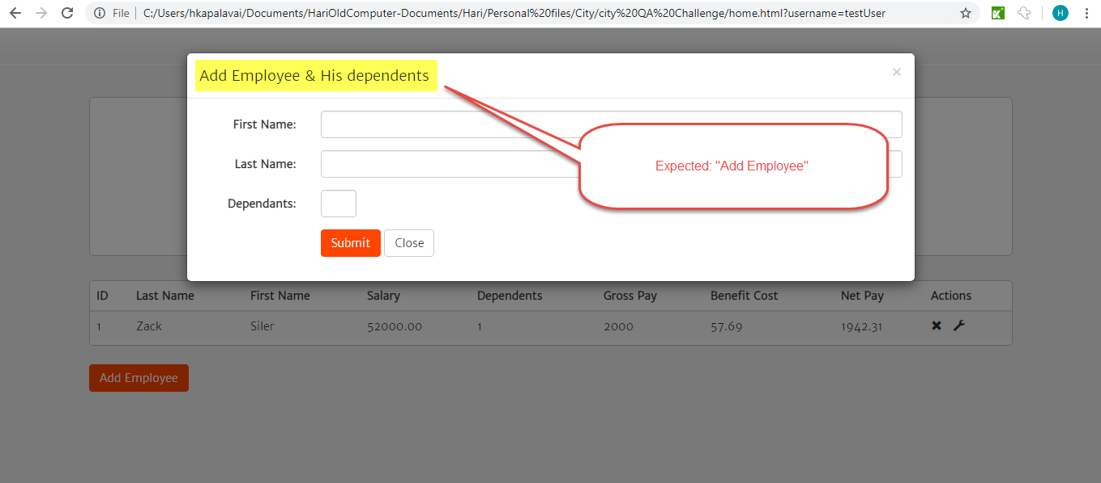

**Defect -2**

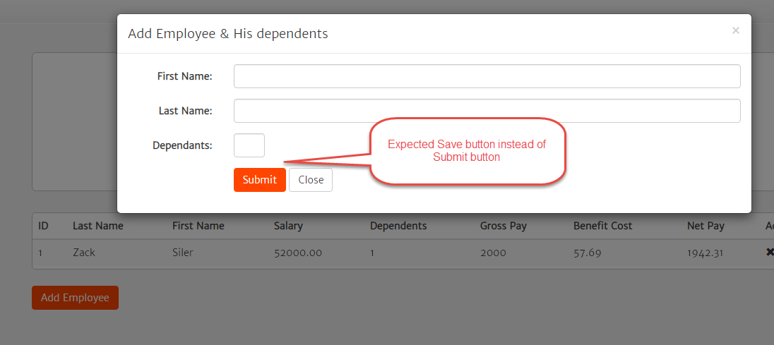

**Defect-3**

